H.T No
Regulations:
A20

Sreenidhi Institute of Science and Technology
(An Autonomous Institution)
Code No:8C627 Date: 16-Aug-2024 (AN)

B.Tech III-Year II- Semester External Examination, August-2024 (Regular and Supplementary)

Artificial Neural Networks (ECE)
Time: 3 Hours Max.Marks:70

Note: a) No additional answer sheets will be provided.
b) All sub-parts of a question must be answered at one place only, otherwise it will not be valued.
c) Missing data can be assumed suitably.

Bloom's Cognitive Levels of Learning (BCLL)

Remember | L1 | Apply | L3 | Evaluate | L5
Understand | L2 | Analyze | L4 | Create | L6

Part - A Max.Marks:20
Answer all QUESTIONS

 |  | BCLL | CO(s) | Marks
1 | What is membrane potential? | L1 | CO1 | [2M]
2 | Draw the diagram of the perceptron model of neuron. | L2 | CO2 | [2M]
3 | Compare between ‘in-star’ and ‘out-star’ topologies of ANN? | L2 | CO3 | [2M]
4 | What is auto-association? | L1 | CO4 | [2M]
5 | What is interpolative behavior? | L1 | CO5 | [2M]
6 | What is counter propagation network? | L1 | CO6 | [2M]
7 | Explain the ADALINE model of neuron. | L2 | CO1 | [2M]
8 | Define Group of instars. | L2 | CO3 | [2M]
9 | Write the name of the activation function in Radial basis function neural network? | L2 | CO5 | [2M]
10 | Explain the Accretive behavior of a neural network. | L2 | CO6 | [2M]
Part – B Max.Marks:50
ANSWER ANY FIVE QUESTIONS. EACH QUESTION CARRIES 10 MARKS.

 |  |  | BCLL | CO(s) | Marks
11. | a) | Explain briefly the terms ‘cell body’, ‘axon’, and ‘synapse’ with reference to a biological neural network? | L2 | CO1 | [5M]
 | b) | Compare the performance of a computer and biological neural network. | L2 | CO1 | [5M]
12. | a) | 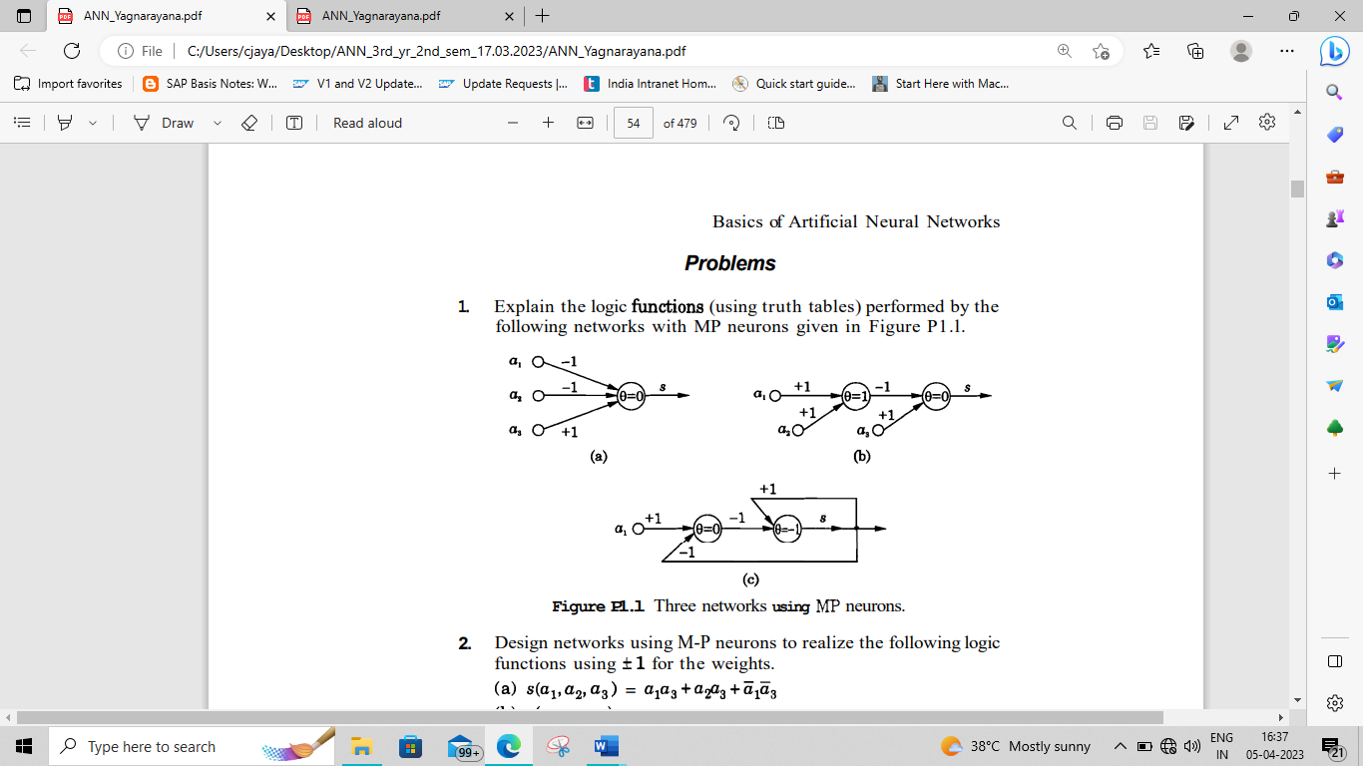  Relize the logic gate functions for the Fig (a) and Fig (b) given, using MP model of neuron. | L3 | CO2 | [5M]
 | b) | Explain the perceptron model of neuron. | L2 | CO2 | [5M]
13. | a) | Discuss characteristics of neural networks. | L3 | CO3 | [5M]
 | b) | Draw single Layer Feed forward ANN and explain? | L2 | CO3 | [5M]
14. | a) | Explain the Hebbian and Delta learning laws in detail? | L2 | CO4 | [5M]
 | b) | What are the three fundamental units? Describe with neat sketches? | L2 | CO4 | [5M]
15. | a) | Discuss pattern classification task with respect to feed forward neural network? | L3 | CO5 | [5M]
 | b) | Distinguish between pattern association, pattern classification and pattern mapping tasks? | L2 | CO5 | [5M]
16. | a) | Explain the architecture of Full counter propagation network and explain? | L2 | CO6 | [5M]
 | b) | Explain the structure of competitive learning neural network. | L2 | CO6 | [5M]
17. | a) | Explain briefly the terms ‘processing unit’ and ‘interconnections’ with respect to artificial neural network? | L2 | CO1 | [4M]
 | b) | Design two input NAND gate using MP model of neuron. | L4 | CO2 | [3M]
 | c) | Draw single Layer Feed forward ANN and explain? | L2 | CO3 | [3M]
18. | a) | Explain the delta learning laws? | L2 | CO4 | [4M]
 | b) | Explain the auto-association task in neural network? | L2 | CO5 | [3M]
 | c) | Explain the architecture of Radial basis function neural network. | L2 | CO6 | [3M]

-- 00 -- 00 –

